**INTRODUCTION**

* 1. **Introduction of the project:**

This project has been undertaken as a fundamental requirement of a BSc (Hons) Information System and Management Studies at the University of Leeds. The purpose is to investigate the current Student Information Systems that are used in university schools. Once this has been done, detailed requirement specification will be generated from the current systems’ investigation, analysis and comparison. The requirement specification will be analysed and evaluated.

This chapter explains the project objectives and the scope of the investigation. The problem domain is described, the key terms are introduced and the structure and format of this report are briefly summarised.

* 1. **Objectives, Requirement and Scope of this studies:**

In order to successfully complete my project, a number of objectives firstly need to be define Investigate what the current Student Information Systems of three different university Schools are. Those chosen systems are: School Information System (SIS) in School of Computing System in Leeds University Business School (LUBS), Student information System in Shanghai University of Finance and Economics (SUFE).Produce a detailed requirement specification for the potential new Student Information System of general university school Evaluate and analysis the requirement specification of the potential new Student Information System.

Within those objectives, the scope of the project has been set. Those three Student Information Systems will be carefully investigated. Due to the vague boundary and relation between university school’s sub-system and university wide system in China, the system in SUFE will also be covered in the investigation to generate a more interesting comparison of three Systems and hopefully, some useful mutually improvement recommendations can be made eventually.

The minimum requirements of this project have been set in the beginning of the project. They are:

Conduct a requirement specification from first principles that will be based around the generic requirement of a typical university school An investigation of potential customers (university school) Business process modelling and information capture requirement

Providing evidence of investigation At least one presentation for summarise requirement specification.

In order to deliver a successful and usable requirement specification for generic university schools, the modelling of those three targeted Student Information Systems and their comparison and evaluation will be critical to the success of this intention

.

* 1. **What is a Student Information System**

First of all, let’s see what an information system is. From the literature review, Sauer (1993) argued that some people will see them as an expense, others as a solution, a control mechanism, a threat to the quality of working life or even as a technical problem in 1993. The diverse perceptions of the Information system resulted in a huge differences in the definitions of IS that are available.

Lucas (1995) describes an information system as helping to control operations in an organization, whilst Laudon &Laudon (2002) defines it technically as a set of interrelated components that collect (or retrieve), process, store, and distribute information to support decision making, coordination, and control in an organization. Information systems are seen as a strategic resource within the organization, that is, they have an important impact on key operations which determine the livelihood of the organization (Martin, 1992).

Student information system literally means the general information systems for maintaining and providing student information. It exists in all the schools, colleges, universities and any other education institutions. However, those information systems vary. Some of them are paper based; heavily manual work is involved in managing and maintaining information such as student personal records files.

However, recently, most schools, even down to the very smallest, utilize computers in some way or another. The uses to which the computers are put vary enormously, ranging from word processing and spread sheet through to worldwide on-line access, complicated user access permission system and vast functionalities.

* 1. **Why do university schools need Student Information System?**

Martin (1992) rightly says that it is probably true that many of today’ s business simply could not function effectively without automated information processing systems of some form or another, so do university schools. All of them have common tasks such as collecting, storing and processing

information regarding their students, staff and the work done within the department. With the increase

of information, it is unwise to adopting the traditional paper based system which is slow to access and

therefore, inefficient. Recent years, many systems were developed either by the universities or the

software companies in order to partially automate many of the processes carried out by the department.

Those developments dramatically reduce the time take in searching information and

should enable the school to maintain precise and up-to-date information. For example, previously,

students would have to enquire for much of his information from the school student office, which

required more time and effort, particularly from members of staff. The new system is more efficient

and also often presents more accurate information. However, those systems vary even within the same

university. Some are quite well developed and implemented, some still adopting the inferior and out of-date technology. This is also one of the project’s aims: to analysis some sample systems in order to attain the strengths and eliminate the weaknesses in developing the new potential student information system.

**2. SOFTWARE REQUIREMENT SPECIFICATIONS**

**2.1 Software requirements:**

* Operating system : Window XP
* Language : C++

2.2 **Hardware interface:**

* + - * + Processor:: Pentium-III (or) Higher
        + Ram:: 1GB (or) Higher
        + Hard disk:: 40GB

**3.** **ANALYSIS AND DESIGN**

CHOICE

Enter valid user name and pwd enter valid uname&pwd display attendance marks insertion successfully

CHOICE

CHOICE

ATTENDANCE INSERT

EXIT

CONTINUE

MARKS INSERT

CONTINUE

CONTINUE

ATTENDANCE

USER LOGIN

ADMIN LOGIN

MARKS INSERT

EXIT

CONTINUE

MARKS

EXIT

ADD USER

EXIT

EXIT

CONTINUE

EXIT

DESCRIPTION

Student information system is contain two modules :

1. Admin login

* Admin can have username and password
* This system is maintained by the department of administrative system
* To insert the attendance and marks of the student
* Admin can also create the new user account for the student
* Details should be correctly entered otherwise you cannot login
* Every student details can be seen by the admin whenever required

2. User login

* User can have user name and password
* The user can view attendance and marks
* The username and password should be entered properly
* User must logout properly in any case

**4. IMPLEMENTATION**

The success of the software product is determined only when it is successfully implemented according to the requirements. The analysis and the design of the system provide a perfect platform to implement the idea using the specified technology in the desired environment. the implementation of our system is made user friendly.

Here in our project create some files using the header file is

#include <fstream>

Using this below code we have to registered the new user .and here also provide the user to user name and password.

void Home_Page::create_user()

{

system("cls");

cout<<"\n\nSTUDENT INFORMATION SYSTEM";

cout<<"\n\n New User Registration";

string username,password;

cout<<"\n\n\tEnter Username and Password:";

cin>>username>>password;

ofstream fptr("userlogin.txt",ios::app);

fptr<<username<<"\n"<<password<<"\n";

cout<<"\n\nNew User Sucessfully Added";

fptr.close();

}

**4.1 USER LOGIN FILES:**

The user login file stores two users

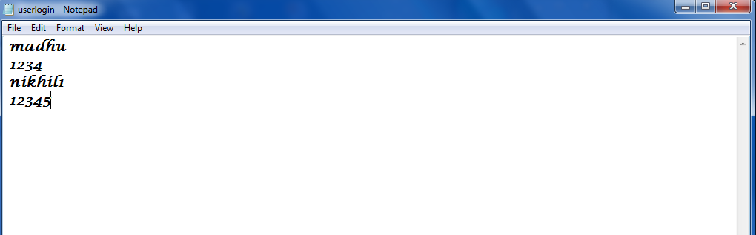

Fig 4.1 user login file

**4.2 ADMIN LOGIN FILE:**

The admin login file stores two administrators

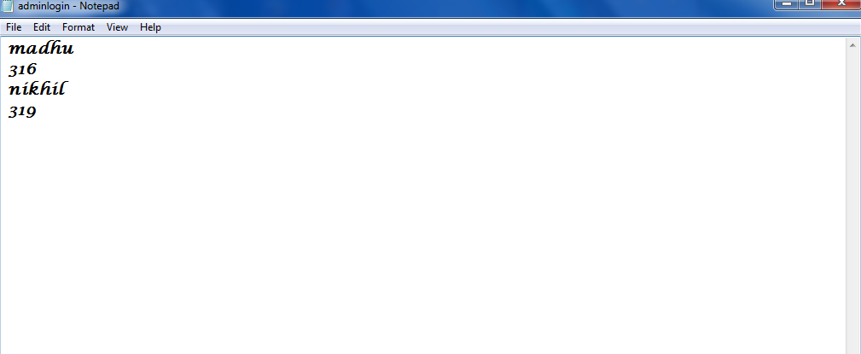

Fig 4.2 Admin login file

**5. RESULTS**

**5.1 Login**

1. When application is opened below screen will be displayed.

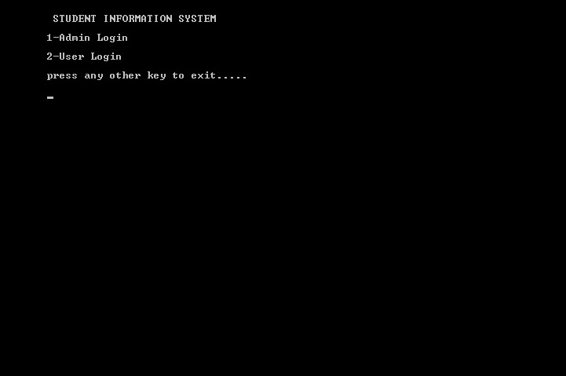

**Fig 5.1** Login

2. The user has to enter 1 to login as Administrator or 2 to login as Student.

3. If you enter 1, then you will be asked username and password. You must enter admin login details.

4. If you enter 2, then you will be asked username and password. You must enter student login details.

5. On successful entry of specific login details user will be directed to respective Admin Page or Student Page.

**5.2 Admin Login**

1. When you login as Administrator, the below screen will be displayed.

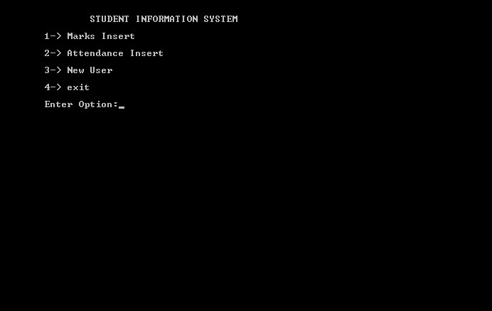

**Fig 5.2** Admin Login

1. Admin can insert marks of all students by selecting **Marks Insert**.
2. Admin can insert attendance of all students by selecting **Attendance Insert**.
3. Admin can also create new logins for students by selection **New User**.

**5.2.1 Marks Insert** 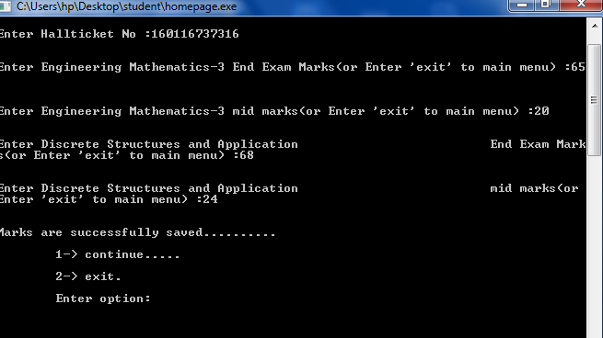

**Fig 5.2.1** Marks Insert

1. Enter hall ticket number of student whose marks to be inserted.
2. Enter all subjects end exam and mid exam marks.

**5.2.2 Attendance Insert**

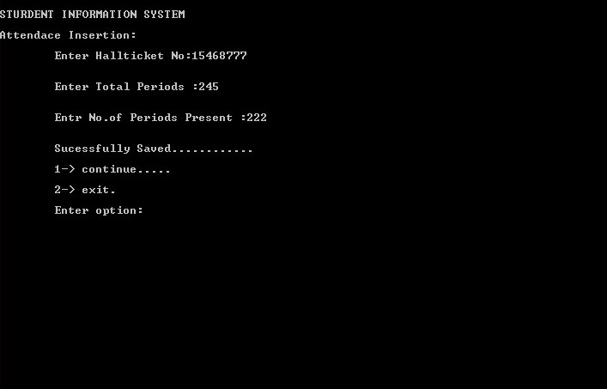

**Fig 5.2.2** Attendance Insert

1. Enter hall ticket number of student whose attendance to be inserted.
2. Enter total number of periods and number of periods present.
3. Successfully saved message will be displayed

**5.2.3 New User**

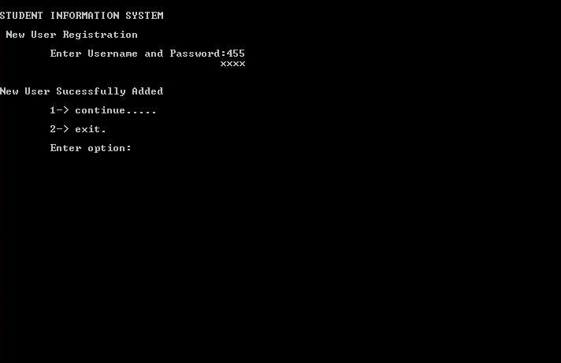

**Fig 5.2.3 New User**

1. Just you have to enter username and password.
2. New user successfully added message is displayed.

**5.3 User Login**

1. When you login as Administrator, the below screen will be displayed.

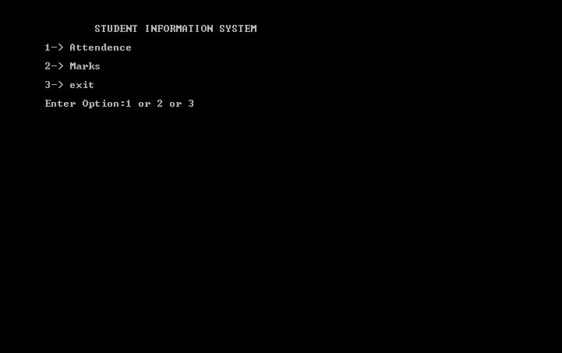 **Fig.5.3** User Login

1. User can check his attendance by selecting **Attendance**option.
2. User can check marks by selecting **Marks** option.

**5.3.1 Attendance**

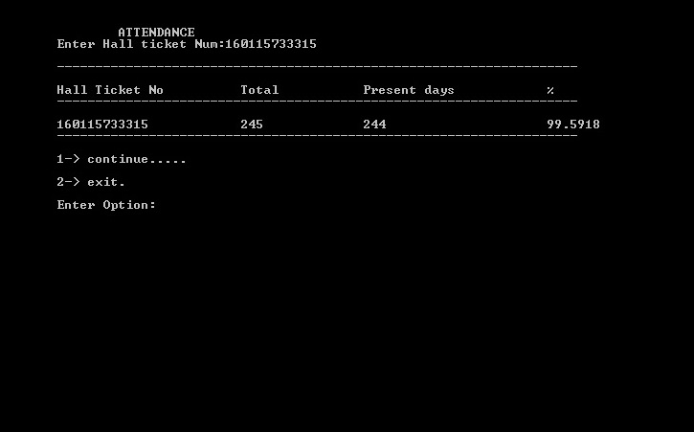

**Fig.5.3.1** Attendance

1. Enter hall ticket number whose marks to be displayed.
2. **5.3.2 Marks**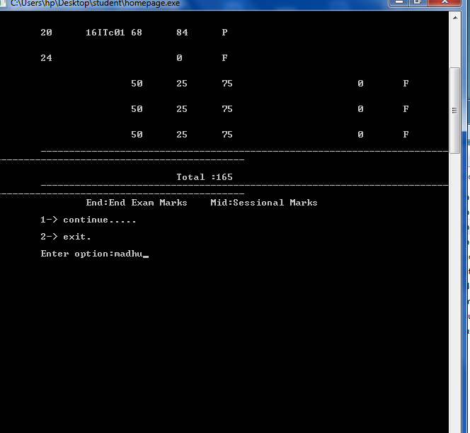

**Fig.5.3.2** Marks

1. User has to enter hall ticket number.
2. Marks of specific student will be displayed.
3. Enter 1 to continue or 2 to exit.

**5. CONCLUSION**

* Teacher can manage attendance using web. So that paperwork can be eliminated.
* Generate attendance report any time which allows teacher to know student is eligible to attend the exam or not.
* Students as well as parents can track grades effortlessly.
* This the project is user friendly approach.

-

**7. REFERENCE &BIBLIOGRAPHY**

**Books:**

1. **Al Stevens, c++ programming, pp.670-700, March 2003**
2. **Balaguru Swami, c++ programming**
3. [**http://astevens@ddj.com**](http://astevens@ddj.com)

**List Of Figires**

4.1 User Login file

4.2 Admin Login file

5.1 Login

5.2 Admin Login

5.2.1 Attendance Insert

5.2.2 Marks Insert

5.2.3 New User

5.3 User Login

5.3.1 Attendance

5.3.2 Marks